**FIELD STUDY ON THE CHALLENGES FACED BY XI STANDARD STUDENTS IN LEARNING PHONETICS AT GOVERNMENT HIGHER SECONDARY SCHOOL,**

**PENNATHUR**

**A Field Study Submitted To**

**GOVERNMENT ARTS AND SCIENCE COLLEGE,**

**ARAKKONAM-631 051**

In partial fulfillment of the requirements for the degree of

**MASTER OF ARTS IN ENGLISH**

by

**R.KAVIYA**

**REG.NO: 35621P02006**

Under the Guidance of

**S.SURESH KUMAR, D.TEd. M.A., M.Ed., M.Phil. SET**



**PG DEPARTMENT OF ENGLISH**

**GOVERNMENT ARTS & SCIENCE COLLEGE,**

**ARAKKONAM- 631 051**

**JUNE 2022**

**FORM-A**

**TITLE OF FIELD STUDY :** The Challenges Faced by XI Standard

Students in Learning Phonetics at

Government Higher Secondary School,

Pennathur.

**LANGUAGE :** English

**NAME OF THE CANDIDATE:** Kaviya. R

**REGISTER NO :** 35621P02006

**AGE :** 21

**SEX :** Female

**DEPARTMENT :** PG ENGLISH

**SEMESTER :**  II

**YEAR :** MA-I YEAR

**COLLEGE ADDRESS :** Government Arts and Science College,

Arakkonam**.**

**RESEARCH SUPERVISOR :** S. Suresh Kumar, D.T.Ed., M.A., M.Ed.,

M.Phil. SET

**CERTIFICATE**

It is certified that Miss. **KAVIYA, M.A.,** Government Arts And Science College, Arakkonam, truly conducted her Field Study entitled, **“FIELD STUDY ON THE CHALLENGES FACED BY XI STANDARD STUDENTS IN LEARNING PHONETICS AT GOVERNMENT HIGHER SECONDARY SCHOOL, PENNATHUR.”** We acknowledge and appreciate her Work.



**S. Suresh Kumar, D.TEd. M.A., Dr. P. Samuel, M.A., B.Ed., M.Phil.**

**M.Ed., M.Phil. SET, Ph.D.,**

Research Supervisor, HOD, PG Department of English,

Government Arts & Science College, Government Arts & Science College, Arakkonam- 631051 Arakkonam- 631051

**R.KAVIYA**

Govt. Arts and Science college

Arakkonam-631 051

**DECLARATION**

**KAVIYA.R**, hereby declare that the Field Study entitled **THE CHALLENGES FACED BY XI** **STANDARD STUDENTS IN LEARNING PHONETICS AT GOVERNMENT HIGHER** **SECONDARY SCHOOL, PENNATHUR** is the result of my original and independent research work, carried out under the guidance of **S. SURESH KUMAR, D.TEd., M.A., M.Ed., M.Phil. SET,** Government Arts and Science College, Arakkonam and that it has not been submitted for the award of any Degree, Diploma, or Fellowship or any other similar titles of any university or institution previously.

**Place: Arakkonam KAVIYA.R**

**Date :**

**ACKNOWLEDGEMENT**

First and foremost I am indebted to the Govt. Arts and Science College, Arakkonam for permitting me to do this field study in the Department of English.

I am immensely thankful to **Dr. P.BAMA, The Principal, Government Arts and Science College, Arakkonam**, for extending her moral support.

I express my sincere thanks to **Dr. P.SAMUEL, Assistant Professor & Head, PG Department of** **English, Government Arts and Science College, Arakkonam**, for his moral support that enabled me to complete this work on time.

I am gratefully acknowledging **S. SURESH KUMAR**, **D.TEd., M.A., M.Ed., M.Phil. SET,** for his prolific and efficient guidance during every move of the writing of my field study. His patience and care, his enormous suggestions for improvement, his correction of errors and his stylistic comments have been invaluable. I gratefully remember once again my mentor.

I am highly indebted to all staff of the PG Department of English, whose valuable suggestions were useful to me in completing this work.

I am thankful to my beloved parents and my friends for their devoted and dedicated services and suggestions during the period of my field study.

|  |  |  |
| --- | --- | --- |
| **S.NO** | **CONTENT** | **PAGE**  **NO** |
| 1.  2.  3.  4.  5.  6.  7.  8.  9.  10.  11.  12. | Introduction  Importance of Phonetic Sounds  Place of Study  Field Study Tools  Statistical Collection  Need and Purpose of Study    Field Study Plan  Statistical Analysis  Study Result  Photographs  Implementing the Solution  Conclusion | 1  5  6  6  6  7  8  15  15  18  25  26 |

**THE CHALLENGES FACED BY XI STANDARD STUDENTS IN LEARNING PHONETICS AT GOVERNMENT HIGHER SECONDARY SCHOOL, PENNATHUR**

**Introduction**

Phonetics is the study of human speech, it includes the study of how sounds are physically produced and how sounds perceived by a listener. Phonology is the classification of the sounds within the system of a particular language. The contemporary society needs people to be very well in English. All wants to speak in English ,it is necessary thing too, but how many of us speaks words in a right way while pronouncing is notable. It is divided into three types according to production (articulator), transmission (acoustic), and perception (additive) of sounds.

Accordingly, there are three branches while gives us crucial Phonetics, namely, Articular Phonetics, Acoustic Phonetics and Auditory Phonetics information about speech sounds. Phonetics place a very important role in improving our communication. All the alphabets and the words must sound correctly; else the content as well as our communication will lack luster and sound unimpressive. Phonetics is the Scientific Study of speech sounds that is described and categorized human sounds, understanding the creation of sounds, comparing and contrasting sounds diagonally language.

Nowadays, the teachers have the responsibility to build the best knowledgeable career for the student in their basic studies. So, here to know the Eleventh standard student’s approach and knowledge in learning phonetics. In schools, Phonetics is introduced by the way of vowels and consonants. The students must know about the vowel sounds and consonant sounds are the basics. In 1888 the International Phonetic Alphabet was invented in order to have a system in which there was a one-sound in language and each phonetic symbol. Someone who knows the IPA knows how to pronounce any word in any language. Phonetics broadly deals with two aspects of human speech: production, the way humans make sound and perception, the way speech is understood. The communicative modality of a language describes the method by which a language produces and perceives languages. Languages with oral-aural modalities such as English produce speech orally (using the mouth) and perceive speech aurally (using the ears)-Language production consists of several interdependent process which transform a non-linguistic message into a spoken or signed linguistic signal. After identifying a message to be linguistically encoded, a speaker must select the individual words known as lexical items to represent that message in a process called lexical selection. During phonological encoding, the mental representation of the words is assigned their phonological content as a sequence of phonemes to be produced.

The phonemes are specified for articular features which denote particular goals such as closed lips are the tongue in a particular location. These phonemes are then coordinated into a sequence of muscle commands that can be sent to the muscles, and when these commands are executed properly the intended sounds are produced. Modern phonetics began with Alexander Melville (1819 -1905), whose visible speech (1867) introduced a system precise notice for writing down speech sounds. Daniel Jones is known as the Father of phonetics. He was a linguist, and professor of phonetics of university college, London. Phonetics comes from the Greek word.

Finally, if they learn phonetics, it helps in recognizing both familiar and unfamiliar sounds, improves pronunciation skills and develops autonomy in words and sounds recognition. Phonetics is the branch of linguistics that examines sounds in a language. Phonetics describes these sounds is using the symbol of International Phonetic Alphabet (IPA). The IPA uses a single symbol to describe each sound in a language. The IPA can be helpful for studying a language, especially languages that use letters that are silent or have multiple pronunciations. Languages like Arabic and Spanish are consistent in their spelling and pronunciation – each letter represents a single sound which a rarely various. English is different. It has many letters with two or more sounds and many letters that are silent. Phonetics is the study of the range of sounds which occur in speech, including the way they are produced by the speech organs and the acoustic properties. Phonology is the study of the distribution of and the relationships between speech sound.

The purpose of the Field Study is to assess the effectiveness of phonological awareness in the specific context among XI standard students. In this field study is refers that phonological difficulties faced by XI standard students. The content of this study concerns that pronunciation error .Here are various findings on the phonetic sound errors analysis of students is given. In this research study, it is done by collecting the data needed from students and the initiation was to conduct a survey on talks, interviews, speeches, and the presentations made bye the students. From the findings, main reasons and issues for students facing the difficult in learn or speak out the sounds were analysed. So, it is wished to focus the results were then used to list possible difficult sounds and asked the students to pronounce them. How they pronounced the words were recorded to be analysed. The students were also interviewed in order to have another measurement to determine the difficulties faced. This study aims at investigating the problems which have been encountered by XI standard students when they try to pronounce the phonetic sounds. This study concerns that most of the students especially higher secondary XI students facing many difficult on sounds of English. So this study is attempted to deal with problem to find the most suitable solution for it, the data of this study is collected by means of recording test and questionnaire.

Most phonetics programmes started to teach the students in a way they see a letter and then say the sound it represents. The students are often taught the letters S,A,T,P,I,N first, so that they can sound out a wide variety of words, then starts to teach starts with anchor charts, colour in the beginning letter, build words with a chart of beginning sounds, learn diagraphs with clip wheels, slap the letter sounds, walk the word , play just swap one, toss and blend with plastic cups. These all step by step methods uses a student to be well in phonetic knowledge.

In the light of communicative language teaching, the students are required not only to have good knowledge of vocabulary and eligible grammar, the four language skill, but also correct pronunciation. Accurate pronunciation is must be achieved in learning English process. Therefore learning English phonetic sounds is great important to the Eleventh students who entered the higher secondary level. Even for their exams or in general language communication. In addition this will help them to have a good job in their future and enable them to communicate with foreigners successfully if they have a chance and the need. Finally, the recommends that : Students who are specialized in phonetic sounds , should obtain a high level of intelligibility, and the sounds pronouncing laboratory should exist in all the higher secondary XI students to practice phonetic exercises for better improvement. The findings showed that the problems of pronunciation are helpful in this survey.

**IMPORTANCE OF PHONETIC SOUNDS**

1. It is important for students to learn **letter-sound relationship** phonics allows young readers to develop new words as they read.
2. To students, with practice, this action becomes so automatic that they are able to easily understand the overall meaning of words while they are reading.
3. Phonics instruction teaches students how to decode letters into their respective sounds, a skill that is essential for them to **unfamiliar words** by themselves.
4. It helps enhances early literacy skills, with speech & language development, gives them a head start at school and with **barriers to learning** .
5. Learning phonics will have a big payoff for the students, the more success of they use to read words, the more **capable and confident** he or she will feel about reading.
6. Phonics instruction helps the **student to map sounds onto spellings**.
7. It is the ability to hear and manipulate phonemes (letter sounds).
8. Phonemic awareness is one of the best predictors of a student’s ability to read fluently.
9. Learning phonetics help in recognizing both familiar and unfamiliar sounds, improves pronunciation skills and develops autonomy in words and sound recognition.
10. The knowledge of phonetics and phonology make English language learner to have a command over the sounds of English speech.

**Place of Study**

Field study took place at Government **Higher Secondary School, Pennathur, Vellore.**

The time period taken for the field study is from December 10

**Field study Tools**

1. Senior's project work. (For Reference)
2. Statistical data for study information.
3. Use to watch various news about phonetics .
4. Videos about phonetics through Mobile.
5. Using XI standard text books.

**Statistical Collection**

I have 20 students for my Field study. Understand the students knowledge level about phonetic sounds. Questionnaires, surveys, Observations. Documents and records, Focus groups.

**Need and Purpose Of study**

1. To know about at least the basic knowledge in phonetic sounds.
2. To pick out the sounds in a word phonetic way.
3. To identify a phonetic sound in the right manner.
4. To understand the different sounds of English. The teachers should make students aware of the specific purpose of phonetic sounds.
5. People speak English but the way of speaking is differ from each person.
6. How English is necessary is the same as the way of pronouncing it. So we use phonetic sounds in speaking to improve our communication skills.
7. It helps to develop knowledge and for getting employment opportunities all over the world in today's globalization context.
8. In order to help student with their speech and hearing.
9. It develops student’s pronunciation skills, and develops autonomy in words and sound recognition.
10. It helps to examine the difference between the source of sounds and the target language that is being learned.

**Field study work plan**

Choosing Place for Study

Choosing tools for study

Formation of Quiz List for Statistical Collection

Statistical Collection

Statistical Analysis

Understanding the Details of the

Problem from the Results

Consulting and Deciding On a Solution

Solution Implementation

**THE CHALLENGES FACED BY XI STANDARD STUDENTS IN LEARNING PHONETICS AT GOVERNMENT HIGHER SECONDARY SCHOOL, PENNATHUR**

#### **Questions Framed for Students**

Student Name :

School Name :

Medium :

Group & Section:

1. Do you understand the different sounds of English?
   1. Yes
   2. No
   3. Very little
   4. No Idea
2. Do you know about Vowels and Consonants?
   1. Yes
   2. No
   3. In text books
   4. Well known
3. Do you know about pure vowels and Diphthongs?
   1. Yes
   2. No
   3. Never
   4. No idea
4. While pronouncing a letter do you notice the letter starts with which sound?
   1. Yes
   2. No
   3. Not always
   4. Sometimes
5. How critical are you to pronounce sounds?
   1. Can’t pronounce
   2. Have Tongue Twister
   3. Different one
   4. Hard to pronounce
6. How many Consonants and Vowels sounds are there?
   1. 24 Consonants,20 Vowels
   2. 20 Consonants,20 Vowels
   3. 23 Consonants,21 Vowels
   4. 18 Consonants, 26 Vowels
7. Identify the sound /i/ in given words
   1. Eat
   2. In
   3. Hindi
   4. Himalaya
8. What are the front vowels?
   1. /i/ /ɛ/ /i:/ /æ/
   2. /i:/ /ei/ /ai/ /u/
   3. /a:/ /u/ /u:/ /a/
   4. /u/ /d/ /g/ /t/
9. Which one is a Long Vowel?
   1. /a:/
   2. /e/
   3. /i/
   4. /u/
10. How many pure vowels are there?
    1. 12
    2. 8
    3. 9
    4. 7
11. Which is the consonant sound?
    1. /p/
    2. /u/
    3. /i/
    4. /ae/
12. Identify the center vowels?
    1. /ʌ/ /ə/ /ə:/
    2. /u/ /u:/ /a/
    3. /u/
    4. /i/
13. Which type of vowel sound is /e/?
    1. Long Vowel
    2. Short Vowel
    3. Mixed vowel
    4. Join Vowel
14. Which one is the sound of Alveolar?
    1. /s/ /z/
    2. /b/ /s/
    3. /g/ /y/
    4. /f/ /h/
15. Which sound deserves the correct transcription of the word “Ooty”
    1. Ooti
    2. Ootie
    3. U:ty
    4. O:ty
16. How many sounds are there in English?
    1. 24
    2. 44
    3. 36
    4. 28
17. Which is the correct sound for come?
    1. /kʌm/
    2. /cum/
    3. /com/
    4. /kome/
18. While saying the word "egg" the lips are in which position?
    1. Rounded
    2. Spread
    3. Square
    4. Semi circle
19. How many Cardinal Vowels are there?
    1. 8
    2. 7
    3. 9
    4. 10
20. Identify the vowels
    1. aeiou
    2. hujio
    3. asda
    4. sdfgh

**Statistical Analysis**

Interview with school students through questionnaires, the study also conducted. Through the study it is learned about the impact on students ‘Correct pronunciation of Sounds'. There is Out of 20 students, 6 students mentioned that they face difficulty while pronouncing the sounds, 4 students face some little difficulties in pronounce. Remaining 10 students is well in pronouncing the sounds which means do not face any difficulties.

**Study Result**

Total number of students: 20

Number of boys: 12

Number of Girls: 8

Low Mark Students: 9 to 12 Marks (6 Students)-30%

Average Mark Students: 12 to 16 Marks (4 Students)_20%

Good Mark Students: 16 to 20 Marks (10 Students)_50%

**Responses received from the students**

1. The students asked to choose different sounds of English among 20 students, all students opted option A.
2. The students are asked whether they know about vowels and consonants, among 20 students, 17 students opted A, remaining 3 opted B.
3. The students are asked if they know about pure vowels and Diphthongs, out of 20 students 17 students opted A and other 3 opted B.
4. The students are asked that whenever pronouncing a letter did they notice the letter starts with which sound, out of 20 students 12 students opted A, 8 students opted B.
5. The students are asked if they felt about critical to pronounce sounds, among 20 students 8 students opted A, 8 students opted B, 2 students opted C and 2 students opted D.
6. The students are asked whether they know about consonants and vowels and consonants sounds, all he 20 students opted A.
7. The students are asked to find the vowel sound in a word, among 20 students 8 students opted A, 12 students opted B.
8. The students are asked to find the front vowels, out of 20 students,18 students opted A, 2 students opted B.
9. The students are asked to choose a long vowel, among 20 students 18 students opted A, 2 students opted B.
10. The students are asked about pure vowels, among 20 students 9 students opted A, 1 student opted B, 4 students opted C, 6 students opted D.
11. The students are asked if they know about consonant sounds all 20 students opted A.
12. The students are asked about center vowels, among 20 students 14 students opted A, 3 students opted B, 3 students opted D.
13. The students are asked about the types of vowel among 20 students 4 students opted A, 16 students opted B.
14. The students are asked to find the alveolar sound, among 20 students 15 students opted A, 5 students opted B, 3 students opted C.
15. The students are asked if they know about correct transcription of a word, among 20 students 12 students opted A, 5 students opted B, 3 students opted C.
16. The students are asked if they know how many sounds in English, among 20 students, 8 students opted A, 10 students opted B, 2 students opted C.
17. The students are asked to find correct sound, among 20 students 13 students opted A, 2 students B, 4 students opted C, 1 student opted D.
18. The students are asked if they say the word “egg” the lips are in which position, among 20 students 13 students opted B, 3 student opted C, 2 students opted D.
19. The students are asked to how many cardinal vowels, among 20 students, 16 students opted A, 2 students opted B, 1 student opted D.
20. The students are asked to identify the vowels, among 20 students, 13 students opted A, 4 students opted B, 1 student opted C, 2 students opted D.

**Photographs**

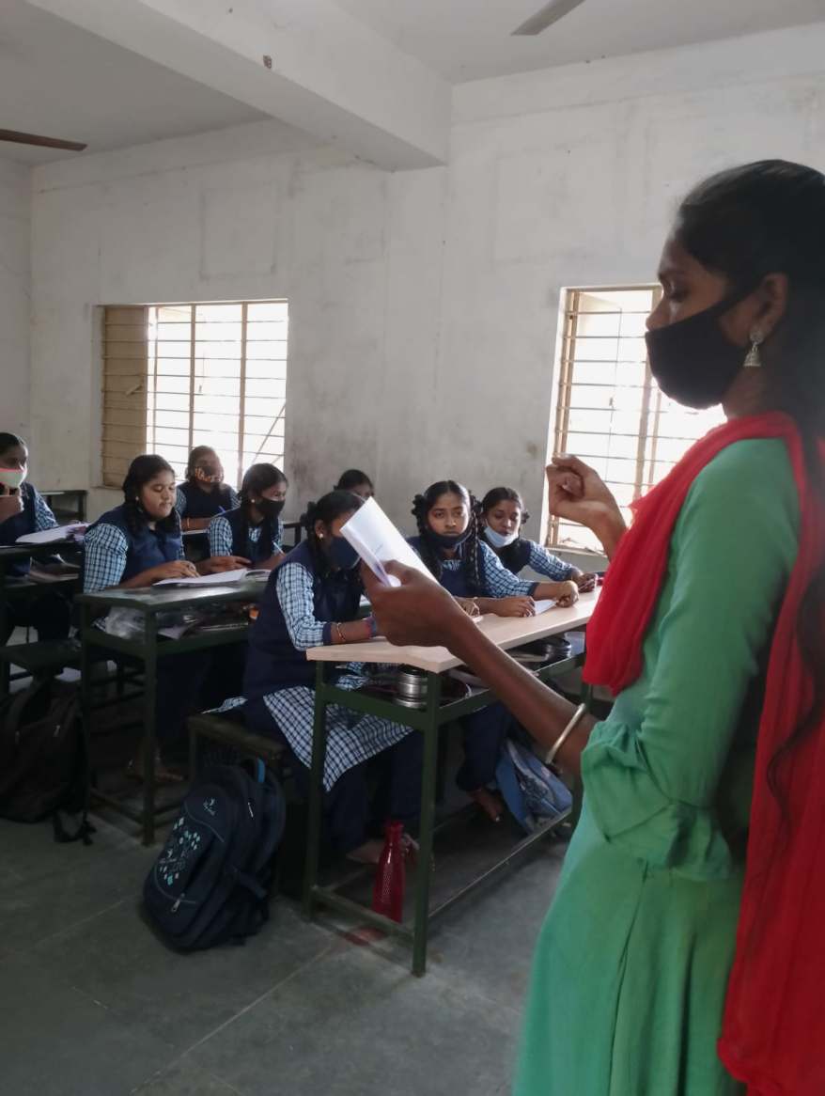

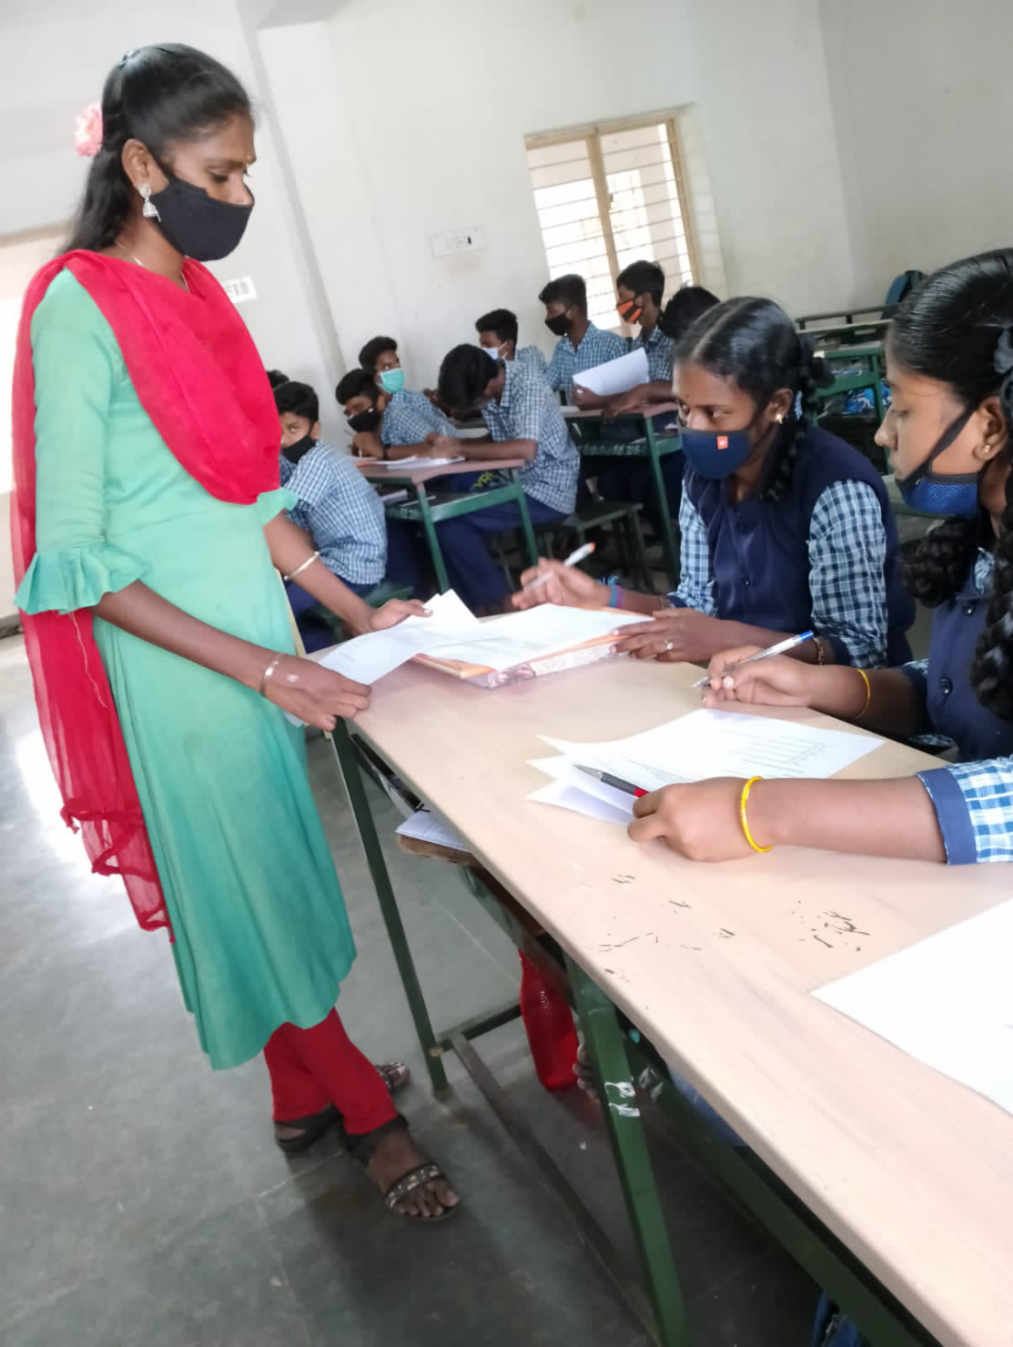



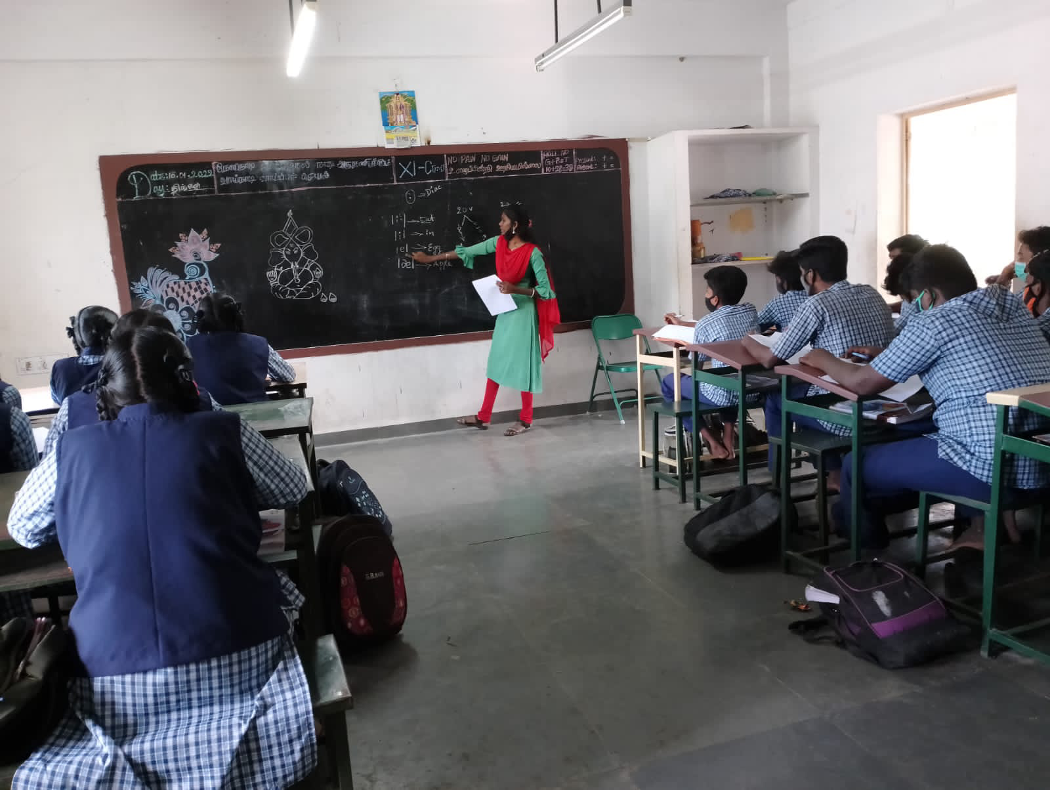

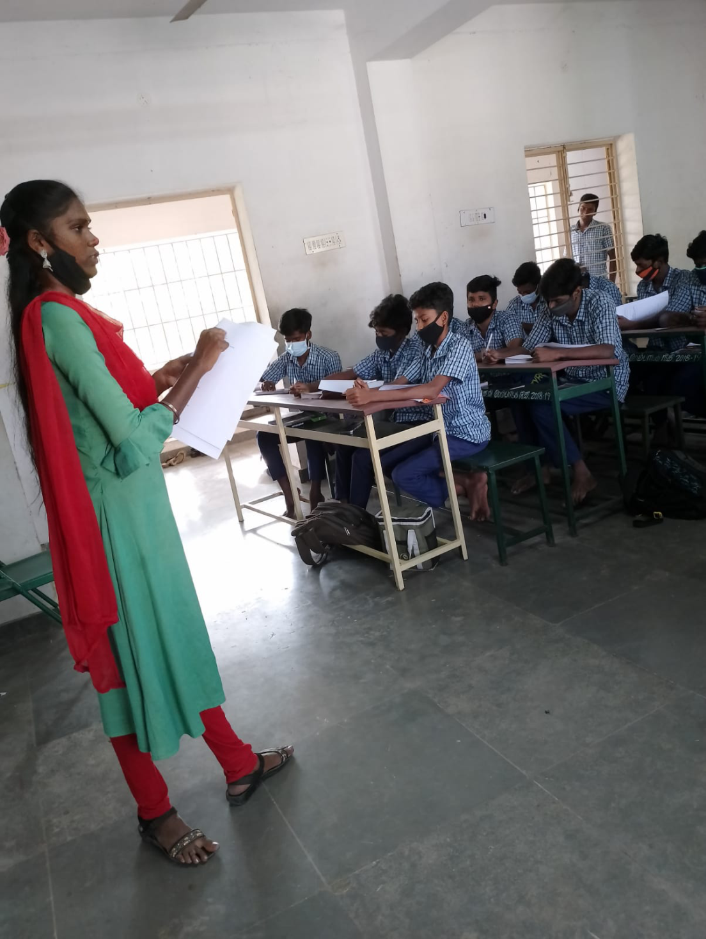



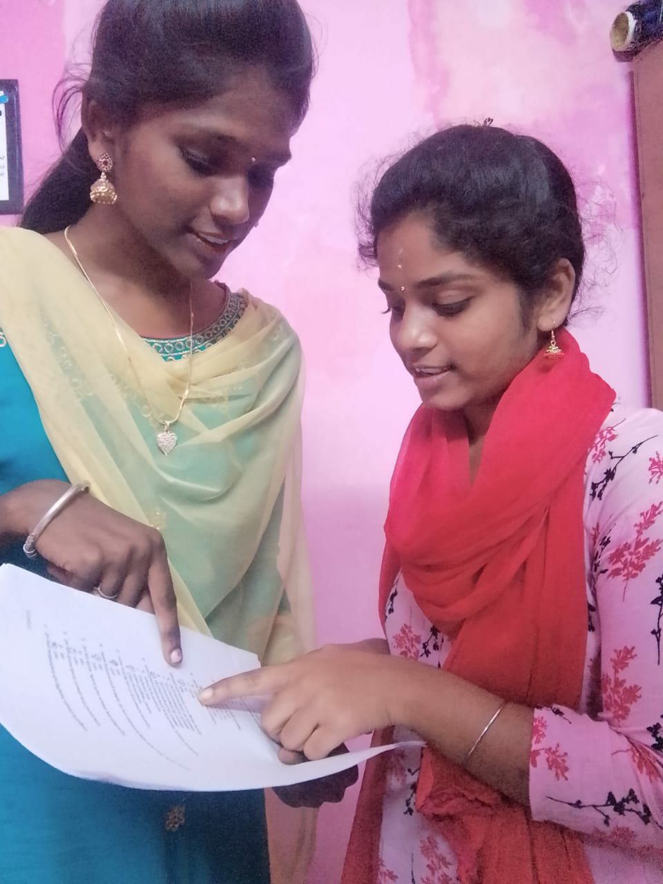

**Implementing the Solution:**

1. The teachersshould mold their students for pronouncing the sounds properly.
2. The teachers must train their students continuously.
3. The teachers ask the students questions that carefully designed so that the students by answering the questions connect the ideas of the text materials with their previous knowledge.
4. Team up with the teacher.
5. Ask how one can highlight phonics and reading outside of class, and share any concerns you have. Listen to the student's sounds pronunciation, Boost comprehension, and Revisit familiar books, Read aloud, and Spread the joy.
6. The teacher try to interact with students in a way of sound and picture match, sing-Along that teach specific sounds.
7. Teach in the method of correlate an individual sound with its corresponding letter or letter group to students
8. It helps them to easily they can hear, identify, and manipulate sounds, the easier it will be for them to decode new words when they are ready to read.

**Conclusion**

The students are able to learn the different phonetic vowel sounds and symbols. They have learned the proper pronunciation and enunciation of words.

Speaking a sentence or word in the way of phonetic sounds is the correct way. It is the success and main concept of the field study. Phonetics provides a valuable way of opening our ears to facets of language that we tend to understand by reference to their written rather than their actual spoken forms. Phonology concerns itself with the ways in which languages make use of sounds to distinguish words from each other. The students are able to learn the different phonetic vowel sounds and symbols. They are able to give and identify the vowel symbols given on the evaluation. They have learned the proper pronunciation and enunciation of words.